How to Install Microsoft SQL Server 2017

In this guide, I’ll show you the SQL Server 2017 installation step by step. You can download it for Windows and Linux, but you can’t install Microsoft SQL Management Studio on Linux at the moment, so we recommend you stick to Windows.

How to install Microsoft SQL Server 2017? Follow these steps:

1. Visit Microsoft’s official [SQL Server 2017 download page](https://www.microsoft.com/en-us/sql-server/sql-server-downloads).
2. Select the edition you want to download. For free use, the **Express** edition is a good choice.  
   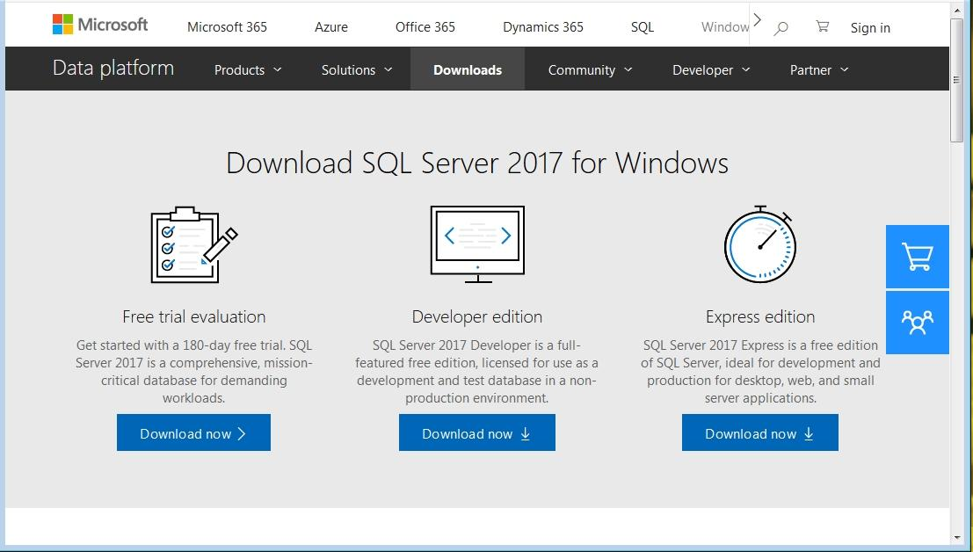
3. Click **Download now** below your selected edition. This will download the installation wizard.
4. The wizard will prompt you to select an installation type. We recommend a **Custom** installation, as this allows you to choose what you want to install from the extended tools.  
   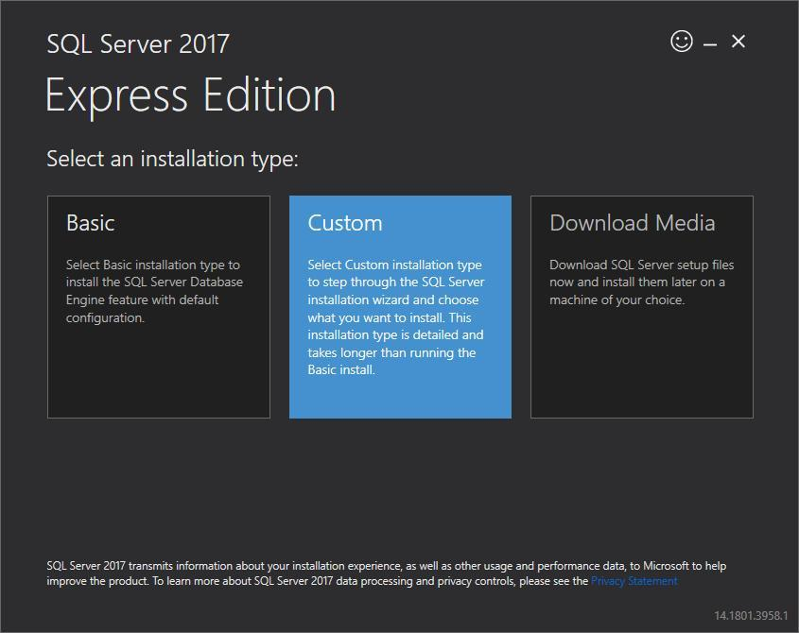
5. On the next page, select a directory for the installation folder. You can leave this as the default or select a custom installation directory.  
   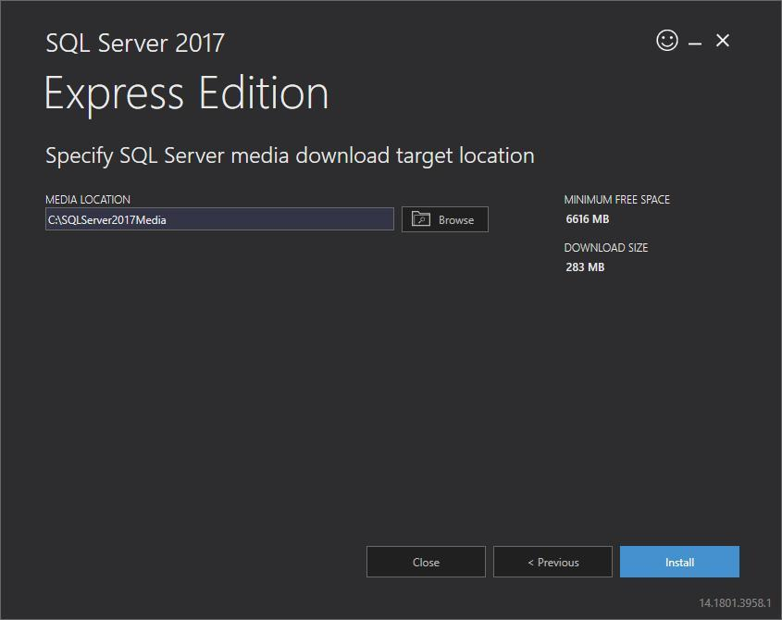
6. 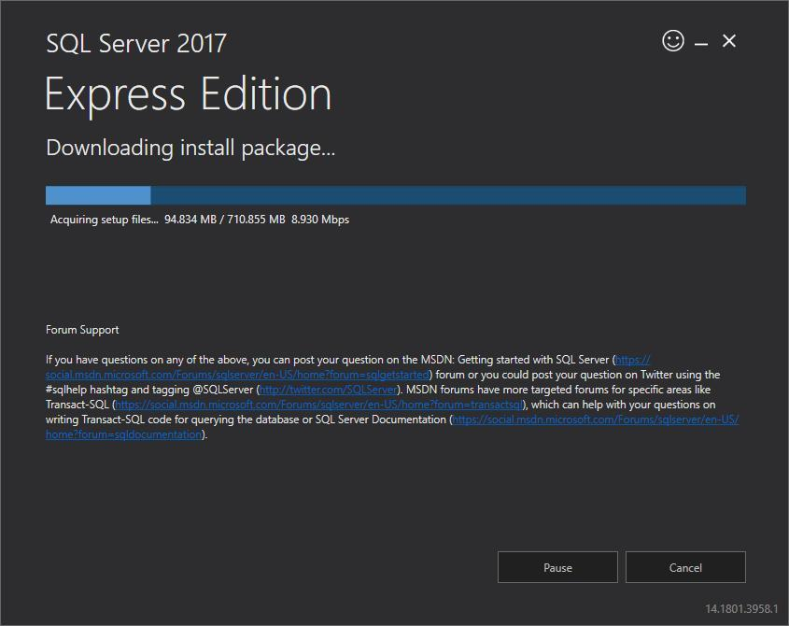Click the Install button to download the installation packages.
7. After the installation package is downloaded, select **New SQL Server stand-alone installation**, as shown below.  
   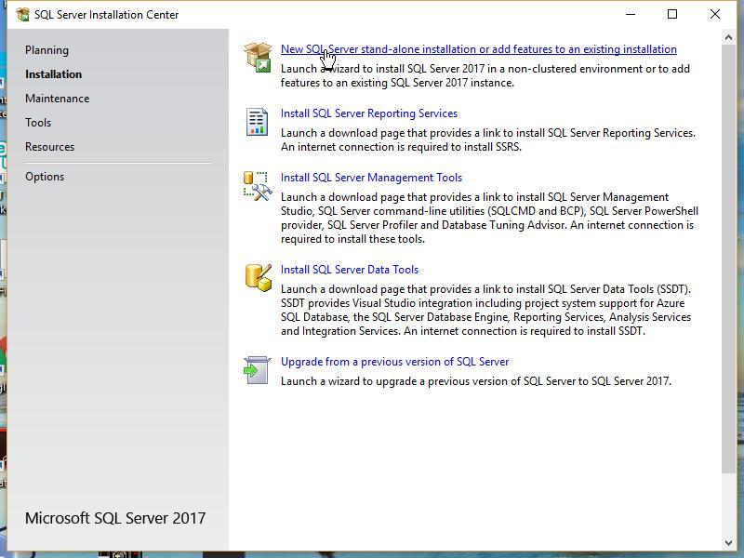
8. On the next screen, you’ll see a setup process. Once it completes, click **Next**.  
   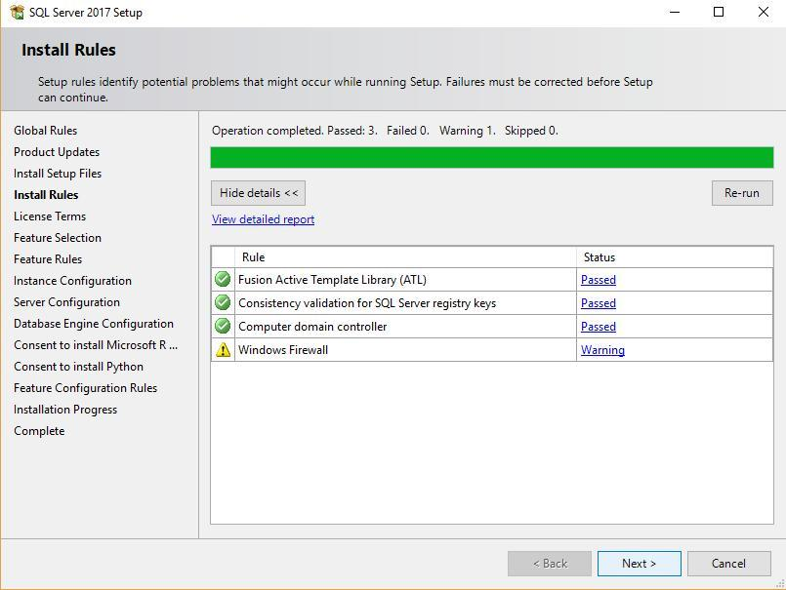
9. You should now see the license terms. Review these if you’d like, and click **Accept**.  
   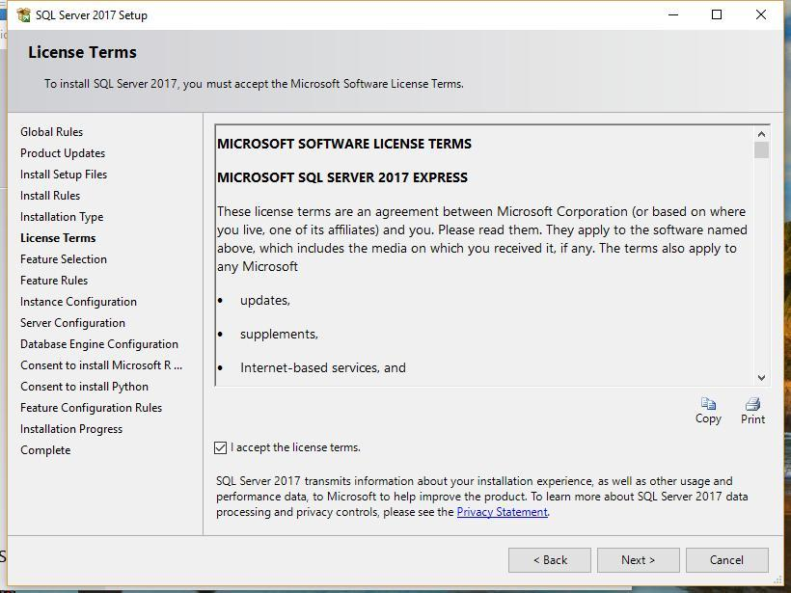

[LearnSQL.com](https://learnsql.com/?itm_source=lsqlBlog&itm_campaign=_default&itm_medium=text&itm_content=platform-2) provides a comprehensive learning experience when it comes to learning SQL. With 30 interactive courses at various levels, the platform will help you to learn the skills you need to tackle reporting in SQL with confidence.

1. You’ll then be taken to the **Feature Selection** screen, where you can choose custom SQL Server 2017 features you would like to install. For example, you can choose to install machine learning services for R and Python.  
   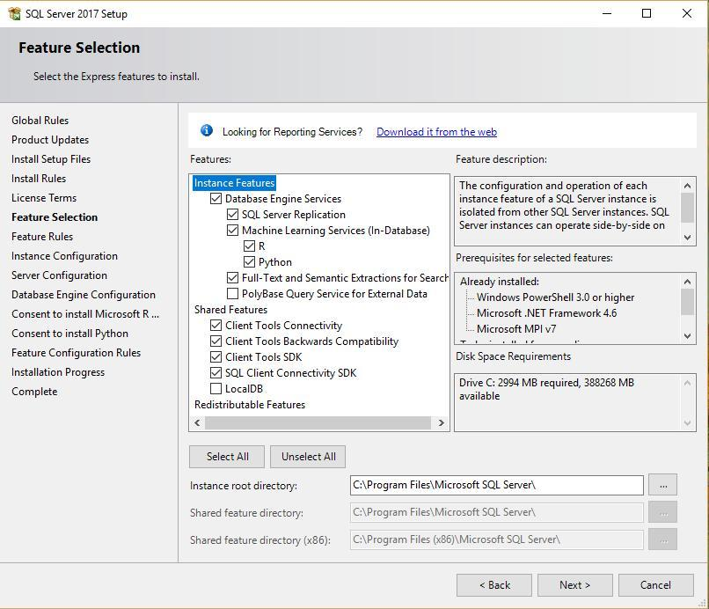
2. Click the **Next** button. You’ll be taken to a screen where you may specify a **Named instance** for your installation. Basically, in SQL Server, you can have more than one instance (a collection of databases run by a single service) of the server. In our example, we’ve chosen **SQLExpress** as our named instance. You can also go with the **Default instance** name.  
   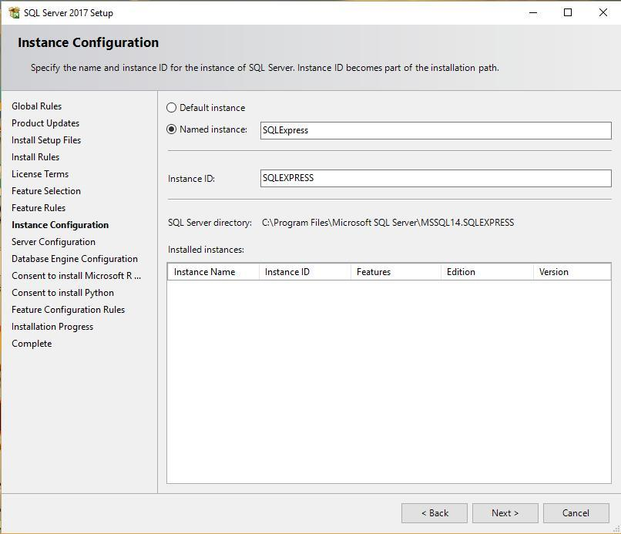
3. Click **Next**. You’ll be taken to the **Server Configuration** screen. You can leave these settings untouched.  
   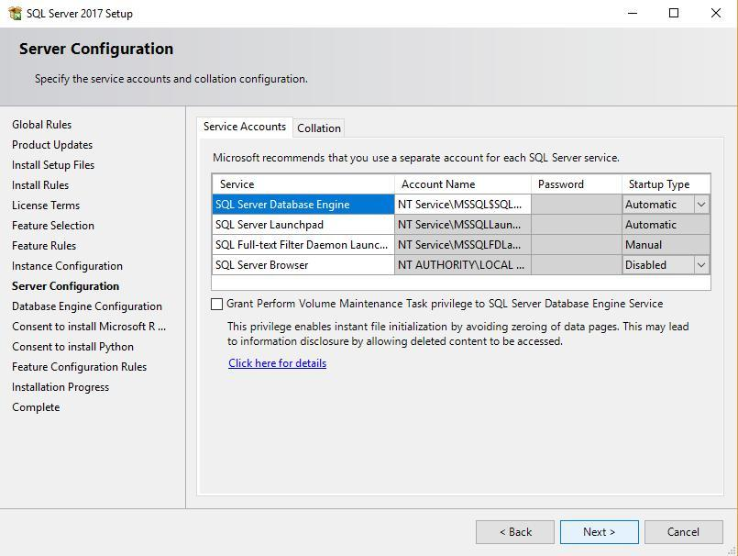
4. Click **Next**. You’ll now see the **Database Engine Configuration** settings. If you’d like to have the option to connect to databases through both Windows and SQL Server authentication, check **Mixed Mode**. Mixed Mode allows you connect to SQL Server using both your Windows account password and also a custom password you can set for SQL Server admin privileges.  
   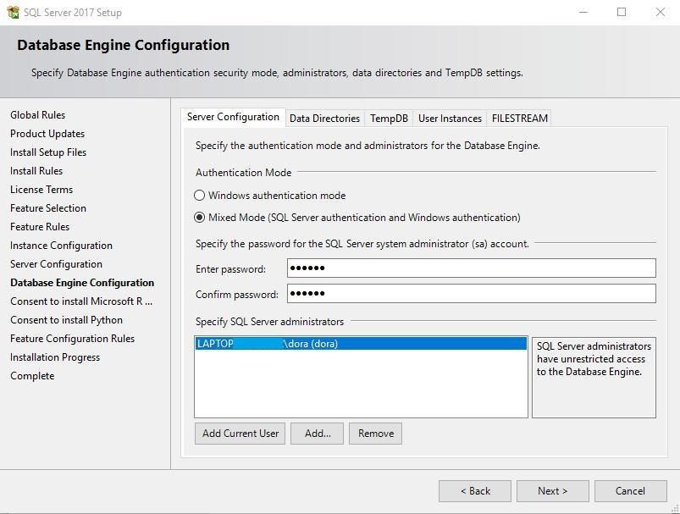
5. Click **Next** to see a summary of the installation process.  
   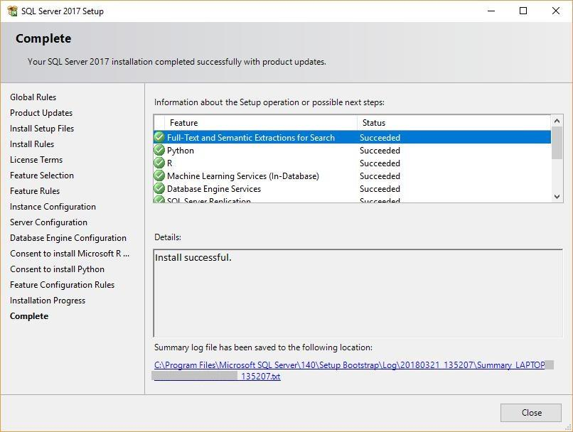
6. Once the installation is complete, click **Close** to finish.

You’re done! You’ve gone through all the SQL Server 2017 installation steps and it’s ready to run on your system.

How to install SQL Server Management Studio

The **SQL Server Management Studio** is a GUI program that allows you to manage your databases quickly and easily, create users, set database permissions, make backups, and much more.

You can install this tool separately by visiting [MICROSOFT’S DOWNLOAD PAGE](https://docs.microsoft.com/en-us/sql/ssms/download-sql-server-management-studio-ssms?view=sql-server-2017) and getting the latest binary for the installation wizard. As of this writing, the latest version is 17.5.

Simply run through the steps and click the **Install** button at the end.

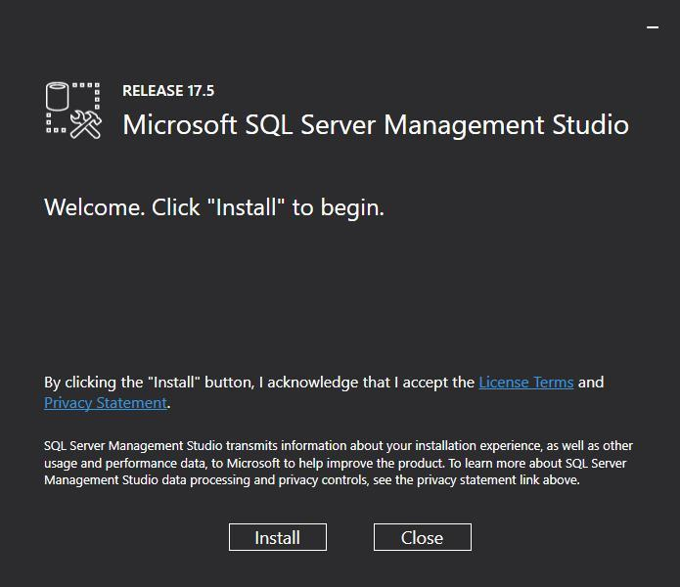 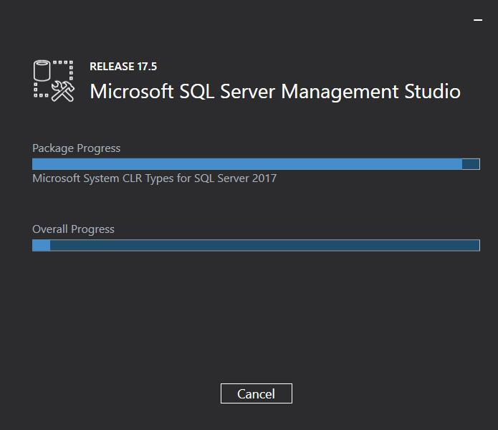 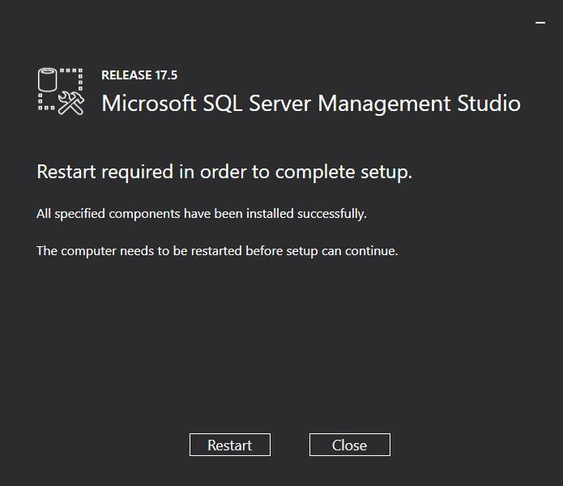

After the installation, the SQL Server Management Studio is ready to launch:

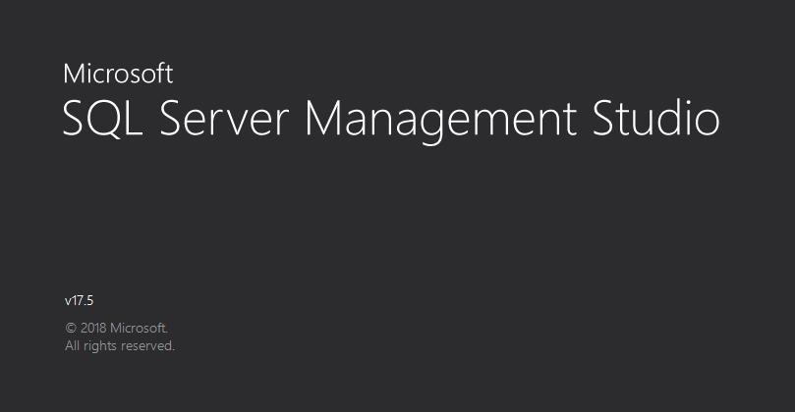

First, you’ll see the **Connect to Server** window. Select the name of the server you’d like to connect to, and enter the login and password for it. Click the **Connect** button.

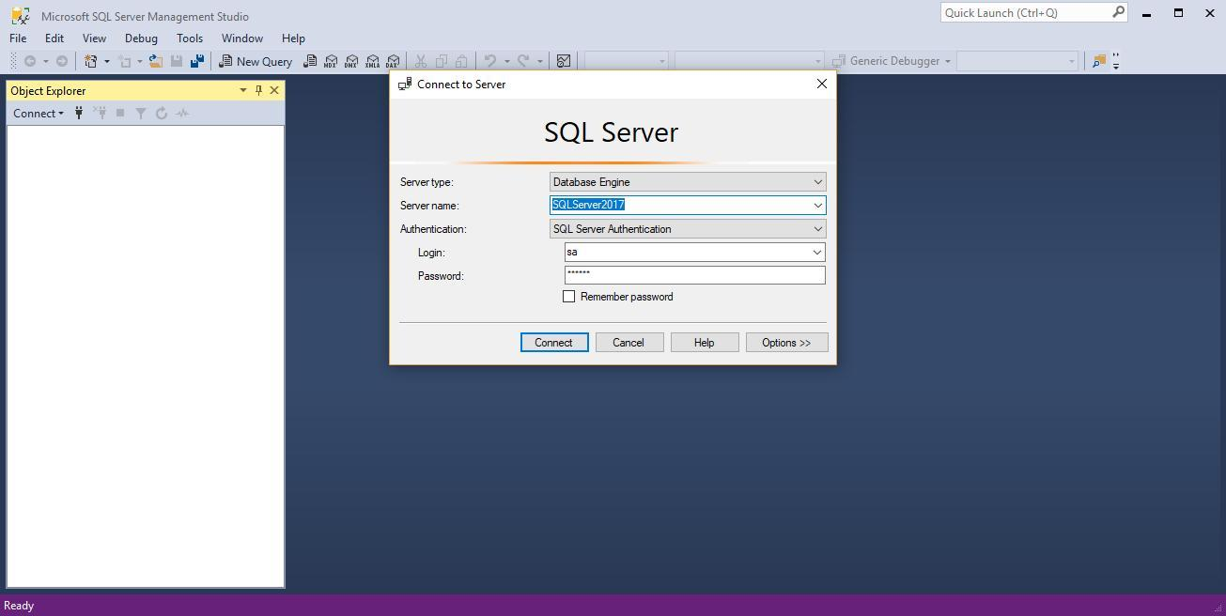

Congratulations!

That’s it! You’re done. You know how to install Microsoft SQL Server 2017 together with SQL Server Management Studio on your Windows.